External Capital Funding Proposal, Nordstrom Inc.
Name
Tutor
Institution
Date

Executive Summary
The purpose of this executive summary is to tell of the need for Nordstrom Inc. to expand into the Chinese market. The Chinese luxury market seems to be improving. The Chinese luxury market is expected to reach a record of $70 billion by 2021. This is a good indication that the company will have a good chance of continuing to grow its profits after having established its presence within the Chinese market. Nordstrom Inc. was founded in 1901 and is currently dealing with shoes, clothes, jewelry as well as perfumes. Since the Chinese have shown an interest in the American brand, it is clear that the company will do well within the market. The company will require a loan of at least $1.5 million.
Investment Project: Description
Nordstrom Inc. is an American company that deals with fragrances, cosmetics, accessories, jewelry, handbags, footwear as well as clothing (Nordstrom, 2020). The company started in Seattle, America, and is looking forward to expanding its global reach into the Chinese market. The Chinese market appears to be an ideal place where the company can establish itself. This is because the Chinese likes to be associated with American brands and Nordstrom Inc. is one of the finest American brands. Therefore, the move to establish its global presence in the Chinese market was reached after having considered the attractiveness that the American brands have in the Chinese market. The company will also be in a position to set a premium price for the products. Therefore, the company will be in a position to end up making more profits from the sales that might be made within the Chinese market.
One of the financial market metrics which appears to be in play is that of time. Every company operates internal as well as external processes. Therefore, a firm needs to measure the time that is taken to start to end a project. Also, the time frame enables managers to have a chance to create a solid baseline data from which they can base their decisions regarding resource allocation as well as human capital. The data that has been collected too gives the managers a chance to identify prime areas for cycle time reduction and setting data-driven goals to make the firm more effective in the future.
Resources
The organization will need not to put up its structures in the first place. This is because of the uncertainties of the future. However, the company will need to lease a shop from already established shopping malls around the strategic places within the Chinese market. The second resource that will be required is that of human labor or human capital (Barbra, 2010). The firm needs to have onboard the locals as shop attenders. However, the firm’s management can only comprise of Americans. Such an arrangement will ensure the firm runs smoothly within the Chinese market. The other resource that the firm needs is that of tech since the world happens to have been taken up by technology in almost all aspects of doing business (Calhoun, 2020). For instance, the shop attendees might be allocated each a tablet so that they can be feeding customer’s responses so that they can help in meeting the specific needs of the customers.
The company needs to establish its new shops within the foreign markets to keep its profit growth. The firm will also need to obtain trade certificates so that it can be allowed by the Chinese government to run its business within the Chinese market. Also, the company will be required to apply for copyrights so that it can be protected from counterfeits that might arise within the Chinese market or in other markets around the world.
Time Frame
The setting up of the shop requires 12 months. This time will be sufficient to have the shop set up and ready to start to operate. The time frame will be as follows:
12 Months before Start-Up
This time will be sufficient to have the business managers be able to turn the idea into an operational business. Within this period the firm reps will have to set dates to meet with some other business professionals such as bankers, accountants as well as business attorneys to discuss the way forward. There is a need before the shops start to operate to obtain licenses, know in advance tax-implications as well as the costs that will be incurred by the start-up.
9 Months before Start-Up
Within 9 months before the start-up kicks-off its operations within the Chinese market, the business representatives who are tasked with processing the required documents will be required to start applying for business licenses as well as permits. The business reps will be required to meet with the city as well as state agencies that are given the mandate to issue business licenses and permits (Kurowski & Sussman, 2011). The company will be looking forward to picking on the best strategic places within the Shanghai city.

6 Months from Start-Up
There are certain documents that the company needs to be applied six months before the set date to kick-start its operation. Since the company will be operating as a corporation, the business reps will be required to start applying for articles of organization and pay for the required filing fees. Besides, the marketing team will also be required to start executing its marketing plan. Also, the business will need to apply for its listing in the local phone directory, creating a bank account and application for loans, and application of its employer identification number with the IRS.
3 Months from Start-Up
Within the last three months to the kick-off of its operation within the Chinese market, the business should have all the required legal necessities dealt with. This is also the period within which the procurement officers of the company should start buying the required equipment and arranging its delivery. The firm’s managers will also be required to apply for a merchant account to enable it to accept credit card payments. Additionally, the human resources will be required to update job descriptions as well as posting job positions to be applied (Kurowski, et al., 2011). Between a weeks to two weeks to opening its doors, the firm’s marketing team will be responsible to ensure that announcements are published in the local business publications.
The anticipated economic life of the company has been approximated to be about 50 years. The company’s progress and survival within the Chinese market will need to be flexible to be able to adapt to the conditions prevailing within the market. However, due to unfavorable eventualities within the Chinese market, the company might end up not operating as earlier expected. When such events happen to occur during the time of operation, the managers need to reconsider otherwise. One of the financial factors that they need to consider before terminating the operation of the business is that of return on investment. If it occurs that the company persists to earn losses after having tried to stabilize it using a variety of approaches, then it will be time to quit the market. The second factor to consider is that of market uncertainties (Kurowski, et al., 2011).
The time of exiting from a certain market comes when the firm happens to be making no profits. There are various ways through which a firm can exit a certain market. In this case, Nordstrom Inc. might choose to be either merged or acquired by some other related companies operating within the area of interest such as the Chinese general supplier Alibaba. Alibaba has appeared to show that it can do well in marketing products internationally as well as domestically. Such a move will bring about economies of scale and enable its operation to enable the firm to make profits.
Justification: Why now
Business strives to establish its presence in an area that appears to be promising in terms of business. With that having been said, it appears that the Chinese market dealing with shoes, clothing, and jewelry as well as fragrances is promising to keep on expanding (Chinese Consumers and the Fashion Market, 2019). For example, the Chinese footwear market is anticipated to hit $70 billion by 2021. This is an important factor that should act as a bait for the company to establish its presence in the Chinese market. Another factor that appears to be attracting the company to establish within the Chinese market is that the Chinese have proved to be liking the American brands. Therefore, the company will make profits that will enable it to continue operating within the company. Between January and April, direct foreign investment decreased. This trend can be partially attributed to the spread of the Covid-19 pandemic. But, this year as of June, foreign direct investment increased by 7.1% to CNY 117 billion. This acts as an indicator the market will soon start performing as earlier anticipated.
Fig. 1.0
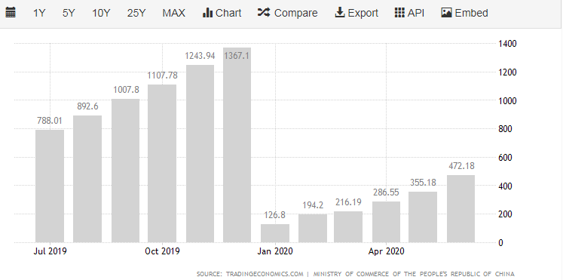
Link:https://tradingeconomics.com/china/foreign-direct-investment#:~:text=Foreign%20Direct%20Investment%20in%20China%20is%20expected%20to%20be%20550.00,macro%20models%20and%20analysts%20expectations.&text=In%20the%20long%2Dterm%2C%20the,according%20to%20our%20econometric%20models.
Justification: Strategic Fit; Microeconomic
Microeconomic factors are one of the things that affect the operation of a business. Some of the microeconomic factors that need to be considered in this case are the price elasticity of the products, the level of competition within the market, and the state of the economy. The state of the economy determines the customer’s spending patterns and therefore determines how much the customers will spend. In case the Chinese market experiences a downfall growth, the spending of the consumers will decrease with time. When the Chinese market experiences growth, then it will lead to an increase in consumer spending. The other thing that the company needs to take care of is that of managing risks and threats that it is exposed to within the Chinese market. Figure 1.1 below indicates that the company is expecting annual revenue growth. A similar trend can be experienced within the Chinese market after the company sets its foot within the market. The company needs to keep its global e-commerce price as well as its divider costs relatively close to succeed within the international markets.
Fig. 1.1
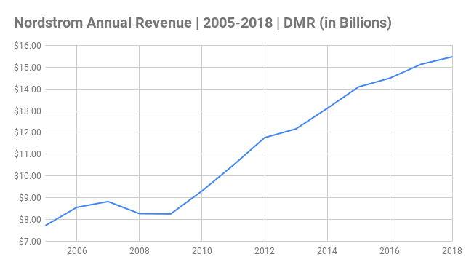
Link: https://expandedramblings.com/wp-content/uploads/2018/09/Nordstrom-Annual-Revenue-_-2005-2018-_-DMR-in-Billions.png
Justification: Comparative Advantage
The company needs to be in a position to have something that will bring out its uniqueness within the market. Such a thing will enhance its core competence and its comparative advantage. In this case, the company has in place personal stylists who are at the disposal of the customers. The customers will be required to log in to their e-commerce or website or check in the company’s brick and motor stores for services. The personal stylists will be able to give the customers the fashion advice that they might require (Berry, 2008). The company will be able to guarantee onsite alterations and tailoring to ensure that its customer’s needs are met. The standby tailors will be ready to perform any alterations that the customers might need to be made at any given time. Such a move will be ensured given that the company will have created a brick and motor store in the Chinese market. Such a move will enhance the experience of the customers. Additionally, the Chinese company will have in place a digital board where the company’s stylists can create digital boards with personalized fashion recommendations (Berry, 2008). For example, the company’s stylists can come up with recommendations for summer vacations, weddings, and other special events taking place within the Chinese community. Such a move will ensure that the company has property intellectual advantage.
Financial Impact
The company will need to ensure that it has adhered to its founding principles to succeed within the Chinese market. The managers of the company will be required to clearly define all services that will be offered through its online platform to ensure that the firm’s objectives and goals are met. The management should have already learned where it went wrong when it tried to establish its presence within the Canadian market. It is such things that will make the company successfully established its presence within the Chinese market. Most of the Chinese fall within the categories of the middle or upper-middle class and it is such that is thought to create a better venture for expansion. Before the company sets its presence within the Chinese market, the firm’s reps will be required to carry out tax analysis. This move will enable the managers to know in advance how the tax regulatory agencies operate. Through such a move, it will be known in advance the possible impacts that it might come across due to taxation practices that are meant for the foreign investors operating within the Chinese market. Since the Chinese like to be associated with the American brands, then this will ensure that the company’s sales volume will be high. Also, the company’s tailors and fashion stylists will have to ensure that the products are tailored to meet the customer’s specifications and needs, there will be increased sales volumes and revenue. Capital purchase costs will be partially reduced since the company will employ partial internal financing. The elasticity of price will ensure that the e-commerce price level is kept close to the company’s price products.
Table 1.
Financial Statements | 2020 |  | 2021 |  | 2022 |  | 2023 |  | 2024 |  | 2025 |  | 2026
Income Statements | 000' | 000' | 000' | 000' | 000' | 000' | 000' | 000' | 000' | 000' | 000' | 000' | 000' | 000'
Sales |  | 18000 |  | 19000 |  | 19500 |  | 20000 |  | 20125 |  | 20185 |  | 20235
Product Cost | 1900 |  | 1950 |  | 1980 |  | 1990 |  | 2000 |  | 2010 |  | 2015
Gross Margin |  | 16100 |  | 17050 |  | 17520 |  | 18010 |  | 18125 |  | 18175 |  | 18220
Equipment Costs | 250 |  | 150 |  | 135 |  | _ |  | _ |  | 100 |  | 100
General Expenses | 550 |  | 500 |  | 450 |  | 425 |  | 475 |  | 410 |  | 395
Payroll Expenses | 150 | 950 | 150 | 800 | 150 | 735 | 150 | 575 | 150 | 625 | 150 | 660 | 150 | 645
Operating Income |  | 15150 |  | 16250 |  | 16785 |  | 17435 |  | 17500 |  | 17515 |  | 17575

Justification: Financial Impact Consolidated
Table 2.
Financial Statements | 2020 |  | 2021 |  | 2022 |  | 2023 |  | 2024 |  | 2025 |  | 2026
Income Statements | 000' | 000' | 000' | 000' | 000' | 000' | 000' | 000' | 000' | 000' | 000' | 000' | 000' | 000'
Sales |  | 18000 |  | 19000 |  | 19500 |  | 20000 |  | 20125 |  | 20185 |  | 20235
Product Cost | 1900 |  | 1950 |  | 1980 |  | 1990 |  | 2000 |  | 2010 |  | 2015
Gross Margin |  | 16100 |  | 17050 |  | 17520 |  | 18010 |  | 18125 |  | 18175 |  | 18220
Equipment Costs | 250 |  | 150 |  | 135 |  | _ |  | _ |  | 100 |  | 100
General Expenses | 550 |  | 500 |  | 450 |  | 425 |  | 475 |  | 410 |  | 395
Payroll Expenses | 150 | 950 | 150 | 800 | 150 | 735 | 150 | 575 | 150 | 625 | 150 | 660 | 150 | 645
Operating Income |  | 15150 |  | 16250 |  | 16785 |  | 17435 |  | 17500 |  | 17515 |  | 17575

The above table. 2 indicates that Nordstrom Inc. is looking forward to earning a profit over the next seven years while operating within the Chinese market. The Chinese market happens to be one of the best international markets for an American company to operate since they like to be associated with American brands. Besides, arguing from an economist point of view, the Chinese market happens to be promising to expand in the future.
Risks
Internal Risks
The most significant internal risks that the company will face when it expands into the Chinese market are public scrutiny, international expansion education, resources, and communication. The people who are tasked with launching the operation of the stores in the Chinese market, they might come across communication issues which might eventually lead to disagreements. It should be well known that the Chinese market is different from the American market and there should be a common language so that the plan can be successfully rolled out. One of the external ways via which the launching plan will be diverted is that creation of a connection between the Chinese government officials and those from the company. The Chinese government officials will be held responsible for ensuring that the company does not go against the ethical as well as legal regulations that the Chinese government has set in place to be followed by international companies. Before launching the stores, the Chinese government officials will have to pay a visit to the sites that will host the shops. There will be a need to have the important resources been put into considerations and therefore the firm’s workers from America will have to come in terms with the fact that things need to be handled in a different way within the Chinese market.
When a company turns out to be a multinational corporation, then it has to be ready to make use of local expertise. The top management executives have to be there when a new store is launched since it acts as a guarantee that they will back up the establishment of the new shop. However, such events might receive significant critics from the public. Such praises or critics will affect the internal environment of the business – the morale of the team working in the project will be impacted in some way (Yoder Visich & Rustambekov, 2016). Besides, such establishments normally come with different internal opportunities. One such opportunity is that of the possibility of an increase in sales volume and consequently an increase in the flow of cash flow. The other opportunity at the disposal of the team working for the company is that of collecting new data that can be used in making a business decisions by the company’s top management.
External Risks
The external risks the company is exposed to when it expands into the Chinese market are localization, mode of entry, customization, and barriers to entry as well as the needs of the customers. Before the company establishes its global presence within the Chinese market, there is a need to ensure that the market is not saturated with the goods which it deals with (Barbara, 2010). The company will be required to buy or construct a shop in the first few stages. Instead, the company should just rent shops in shopping malls that are strategically located and they are busy. Mode of entry as well as the barriers to enter into the foreign market. The company appears to have navigated in the right direction when it comes to expanding its global reach. It has set up an outlook which assists it in navigating into the future. The multinational companies seem to be competing globally to improve on profits, remaining competitive, gaining larger market shares, and diversification of their markets as well as customer bases. The company might realize such by creating connections as well as partnering with the local Chinese government officials to be able to carry out its processes smoothly.
The other risk which the company is exposed to when it expands into the Chinese market is that of customization and localization. Customization and localization in this case will take the form of colors and designs that are most liked by the Chinese. For the organization to mitigate this risk successfully, the officials need to ensure that the products that are sold within the Chinese market are tailored to meet the needs of the customers within the area. The customers found within the market might need products that are of a certain design as well as the color combinations (Barbara, 2010). Therefore, to ensure this kind of risk is diverted, there is a need to have the officials carry out the investigation to ascertain certain designs or brands as well as the color combinations that are liked by the Chinese.
Microeconomic Risks
The most significant microeconomic risks that Nordstrom Inc. might face when it establishes itself in the Chinese market are product distribution, stiff competition, and the locations where it can set up its stores. The location of a store is important since it has to be prime; a place where there will be more customers flowing in and out. The company can learn from its past creation or from other multinational companies that have tried to establish themselves in foreign markets (Besanko & Braeutigam, 2014). Companies normally compete for the available customers and must be prepared to do the same with the companies operating within the industry in question. The other risk is that of the distribution of its products in the different locations where its stores will be set up. Before its establishment is finished, the officials should come up with a plan though which they will be in a position to ensure products are distributed to the different areas. In this case, it will be advisable for the company to pick a logistics company that operates within the Chinese market.
Alternate Financial Scenarios
The expansion that the company wants to accomplish is budgeted to cost between $1.5 million and $2.0 million. The organization will be able to establish 8 stores in eight different locations within the Chinese market. This amount is much but considering the financial strength of the company, this amount will not be able to destroy the entire establishment in case it fails.
Sales Fall
When a company is about to start operating in a new market, the business officials have to come up with some sales projections. If a sales fall 20% short of the sales projections are registered, then there are certain actions that the business officials must make. The location of the shops when a company goes global-wise is an important factor. Therefore, if the organization sets up its retail stores in specific shopping malls, then it will have to affect the rest. If it turns out that there happen some stores to record a 20% shortfall in terms of sales, then it is the work of the managers to check on the causes. In the case of a 20% sales increase, it becomes easier to reach for a decision. But, it will be good for the officials to consider finding out the source of the increase in sales. In case, they note that the increase was recorded due to an increase in sales of certain shops, it will be a good to investigate the reasons for such occurrence.
Time Value of Money
The net present value of this investment will have to be put into comparison with its present three-year average net income. The company happens to have earned a net income of $463 million and its three-year average assets are valued at $7.9 billion with an average return rate of 5.9%. If the investment to be made within the Chinese market happens to yield an amount that will be above 5.9%, it will be wise to continue investing. However, in case its investment ends up earning something equal to 5.9% or below will be wastage of time and resources and the firm will need to divert the resources into other meaningful investments. The exchange rate of the Chinese Yuan was at $1.00 to 1.5 Chinese Yuan in 1995. But things appear to have taken a different direction up to 2015 since it exchanged at $1.00 to around 9.00 Chinese Yuan. Presently, the exchange rate rests at $1.00 to 6.98 Chinese Yuan. This is a clear indication that the Chinese Yuan is gaining strength and this will be of advantage to the company since it will make more profits.
Financing
Global Capital Markets
A firm that is seeking funds to help it finance its operation can either find them internally or seeking funds from an external source. The internal funding sources that are at the disposal of the company are found within its assets as well as its revenues. External funds are sourced from outside the company such as banks, venture capitalists, or some other financial institutions. Most businesses turn into using internal funding because it is a simple and direct way to obtain capital for expansion. The costs incurred in using internal capital to finance expansion is low (Khan, 2010). They do not involve interest fees. In case of an external source such as a loan obtained from a commercial bank, it will entail various costs that will end up becoming expensive to obtain. Also, loans from commercial banks require assets to be held as collateral security. In the case that a certain asset has been listed as collateral security, it becomes not easy to liquidate it before the loan is repaid in full (Schmidt-Gothan Gessner & Lübben, 2002).
Internal funding too has its cons. One of the cons linked to internal funding is that there is a limit to growth. The organization’s available assets of funds might not be enough to cater to the expansion been expected. Therefore, it ends up putting a strain on the company in case it tries to do much using the available capital.
The most viable financial alternative is that of using internal financing. The organization requires at least $1.5 million to establish its presence within the Chinese market. Such an amount will not put the company at risk in case it fails to work as earlier expected. This amount is far much low compared to income which the company earns, for instance, the firm earned an average income of $564 million back in 2018.
Financing: Business Combination
There are various forms that business combination takes. Two of the most common business combination forms are acquisitions and mergers. Business combinations make the companies combining to become stronger. In this case, Nordstrom Inc. can combine with Alibaba.one of the factors that could make it possible or viable to have the company acquired by Alibaba is that of overall growth. It reaches a time when a company cannot grow any further and on being acquired it starts to make a profit once again. The company acquired might be in a position to take a market share without having to do all the work. The business combination makes it possible to have cost-savings (Barnes Ernst & Young, 2019). The companies that combine, eliminate the duplication of work to save on costs incurred. However, after having considered things such as costs incurred and several other things, it is clear that Nordstrom Inc. need not to be combined with another company.

Track Record: Financial Performance
The company seems to be financially doing well. The organization’s key performance indicators (KPI’s) appear to be showing that the company is doing well in terms of financial stability. The organization’s annual earnings per diluted share outlook were recorded at $3.50 from $3.30 in 2019. Also, the earnings before interest and taxes seem to be looking good since last year.
Fig 1.3
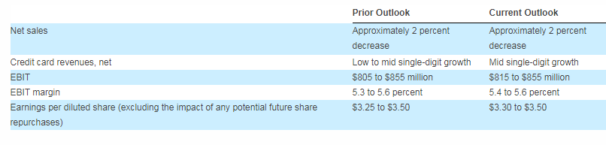
Link:https://www.businesswire.com/news/home/20191121005848/en/Nordstrom-Reports-Quarter-2019-Earnings
The company’s operating net profit after taxes seems to have improved. The company improved its operating net profit after tax between the years 2018 and 2019. This indicates that the company is improving its financial stability over time.
Fig. 1.4 (Amounts in Millions)
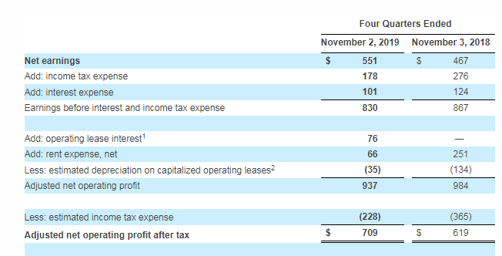
Link:https://www.businesswire.com/news/home/20191121005848/en/Nordstrom-Reports-Quarter-2019-Earnings
Track record: Legal and Ethical
The company has been on the lead in striving to resolve labor-based disputes, price issues as well as some other kinds of issues. In addition to that, the company has in place a concrete set of code of ethics that enables it to handle cases without leading to some other more complicated cases.
The company has got in place a code of ethics that its employees are supposed to follow. The company’s set code of ethics is usually clearly outlined in a handbook that is given to all its employees (Nordstrom, 2020). Through the set code of ethics, the employees can maintain customer’s confidentiality.

Questions and Answers
How old is your business?
Nordstrom Inc. is an American company that was started back in 1901 therefore, the company has over 100 years in operation.
How much is the company making?
The company seems to be making a profit. The company made an average income of $564 million in 2018.
How much are your debts and assets?
The current amount of debt is $5.10 billion. The company boasts of having $9,737 million and the company’s debt to equity ratio is
What is the purpose of the loan?
The purpose of this loan is to finance the expansion of the company to the Chinese market. The Chinese luxury market is expected to grow up to $70 billion by 2021. Also, the Chinese have proved to be associated with American brands. Therefore, this is a wise move for the company since it will be able to capture the new market.
Why have you chosen our bank?
Although this question is not meant to determine a company’s credit-worthiness, it can earn the company some bonus points since it shows loyalty.

References
Barbara, T. (2010). All Abroad: Retailers Head Overseas to Boost Growth. CNBC Markets, https://www.cnbc.com/2010/06/03/all-abroad-retailers-head-overseas-to-boost-growth.html.
Barnes, J., & Ernst & Young. (2019). International GAAP 2019: Generally accepted accounting practice under international financial reporting standards.
Berry, T. (2008). The Plan-As-You-Go Business Plan. New York: Entrepreneur Press.
Besanko, D., & Braeutigam, R. R. (2014). Microeconomics.
Calhoun, G. (2020). Price and Value: A Guide to Equity Market Valuation Metrics.
CHINESE CONSUMERS AND THE FASHION MARKET. (2019). S.l.: SPRINGER.
Khan, M. Y. (2010). Financial services. New Delhi: Tata McGraw Hill.
Kurowski, L., & Sussman, D. (2011). Investment project design: A guide to financial and economic analysis with constraints. Hoboken, N.J: John Wiley & Sons.

